**Fake Product Detection using blockchain using QR code**

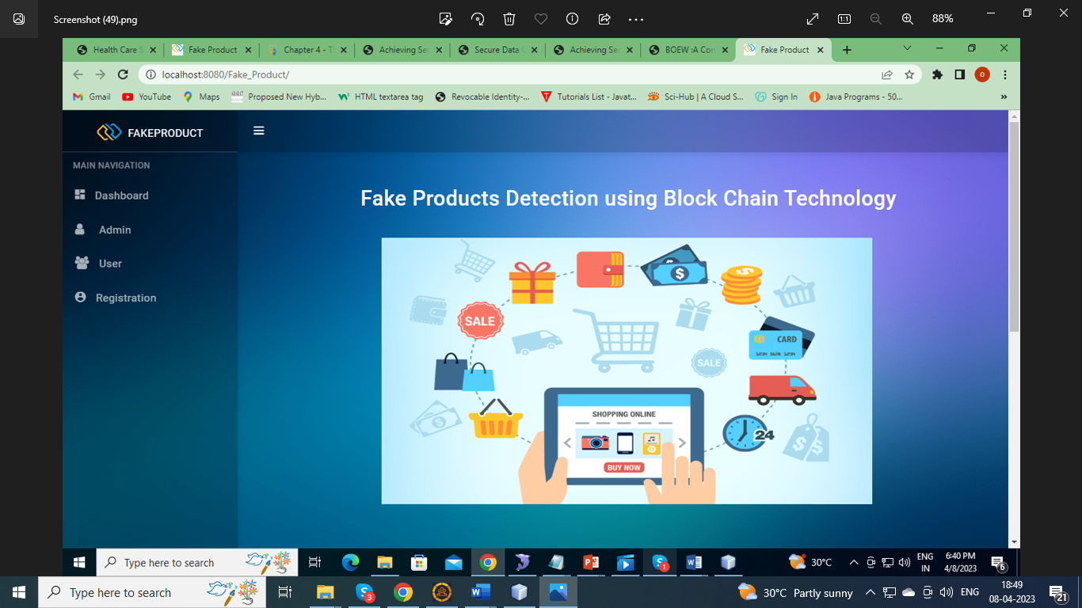

Figure:1 Home page

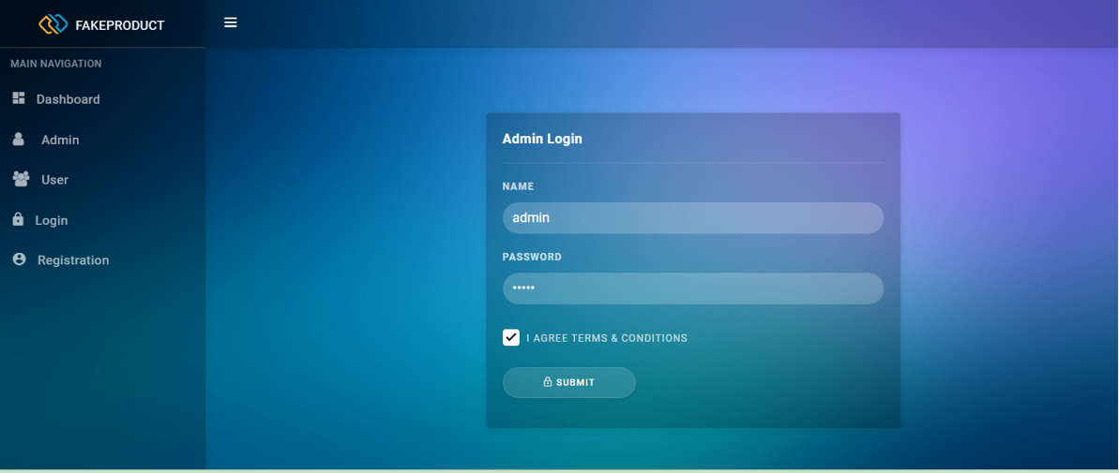

Figure:2

Admin Login

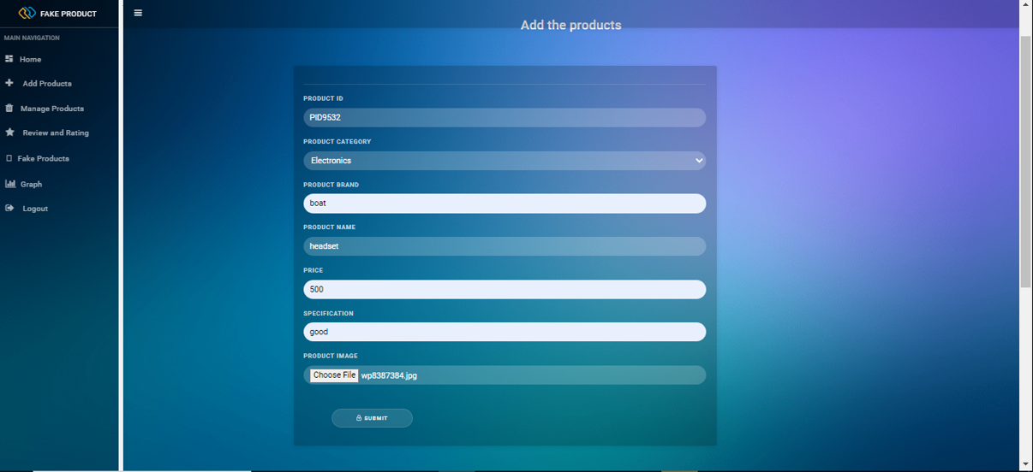

Figure:3 Add Products

The admin can add the Products details

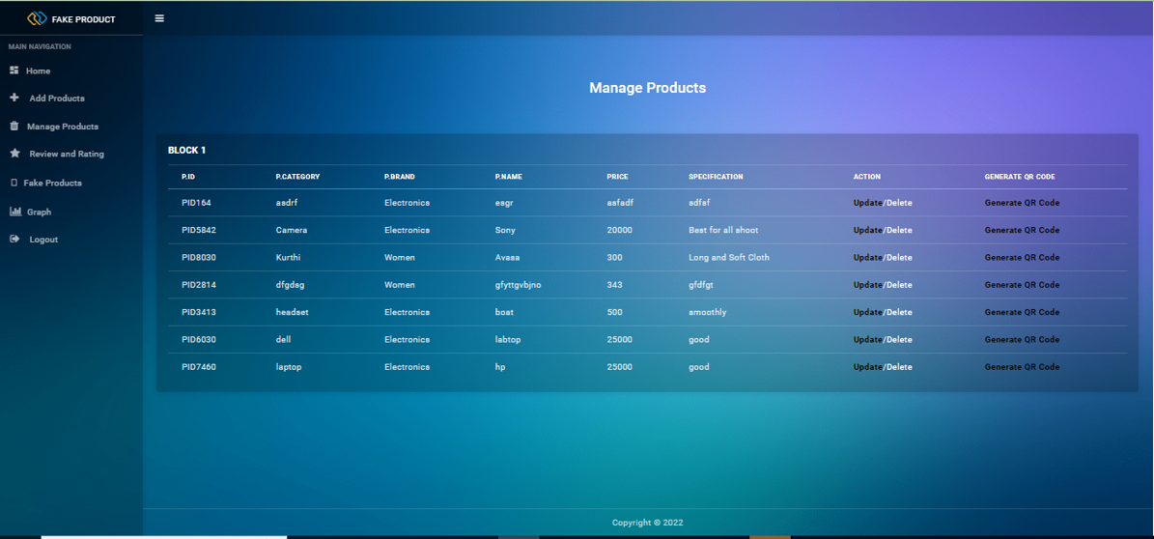

Figure:4 Manage Products

View all added Products details and generate the QR code to store the details. If the product is not available means we will delete the Product.

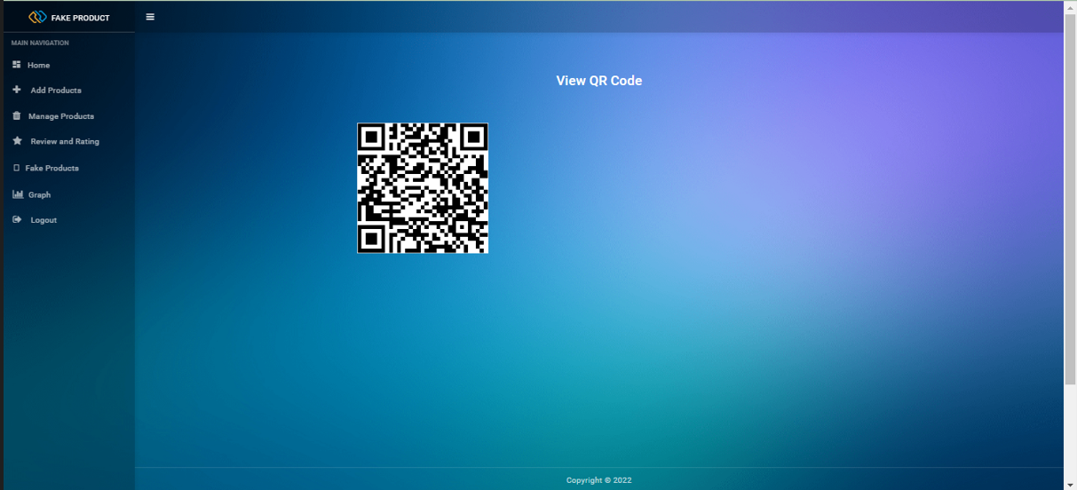

Figure:5 Qr Code

In tha QR Code all the added Details will be shown.



Figure:6 User Login



Figure:7 Profile

User can view their own details

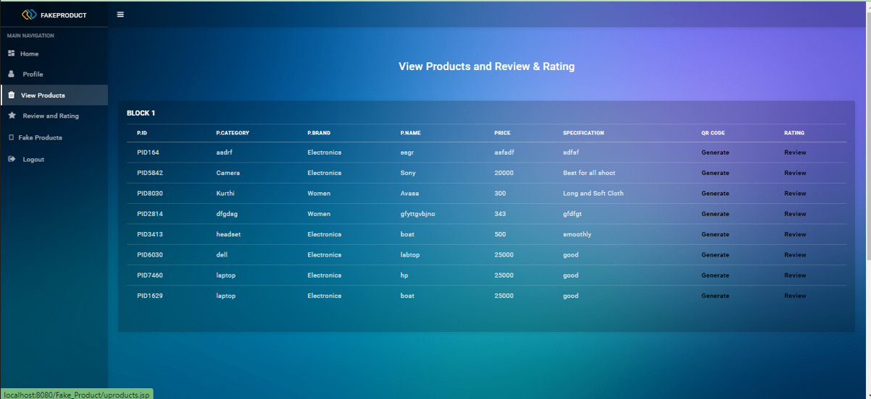

Figure:8 Give Review

View all the products and give review and Ratings to particular products.

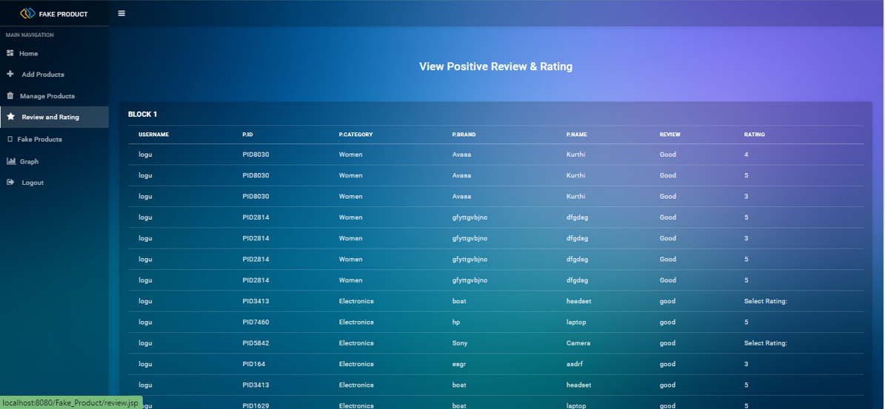

Figure:8 Rating

View all the products positive review and Ratings form the users

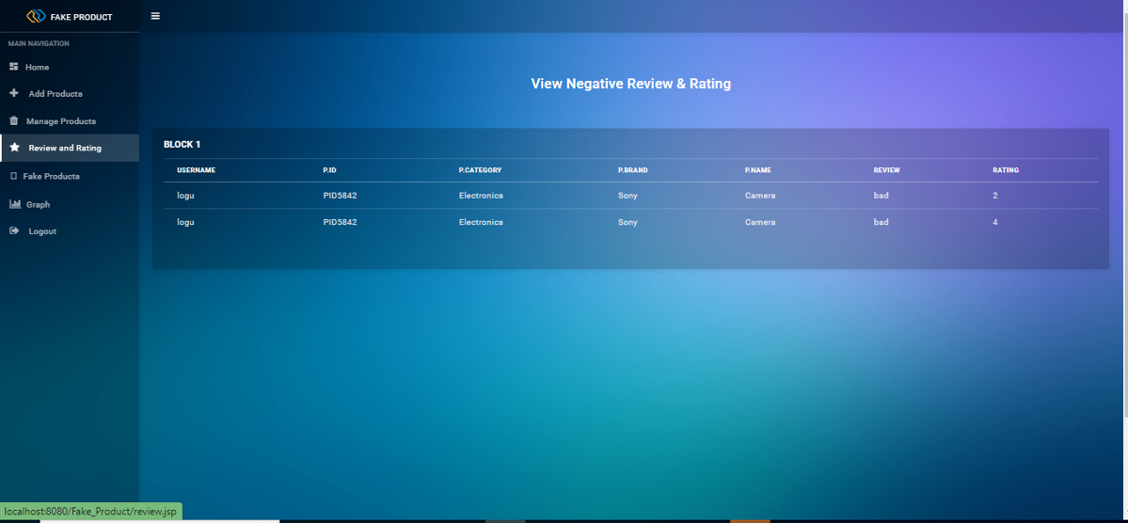

Figure:9 Rating

View all the products Negative review and Ratings form the users

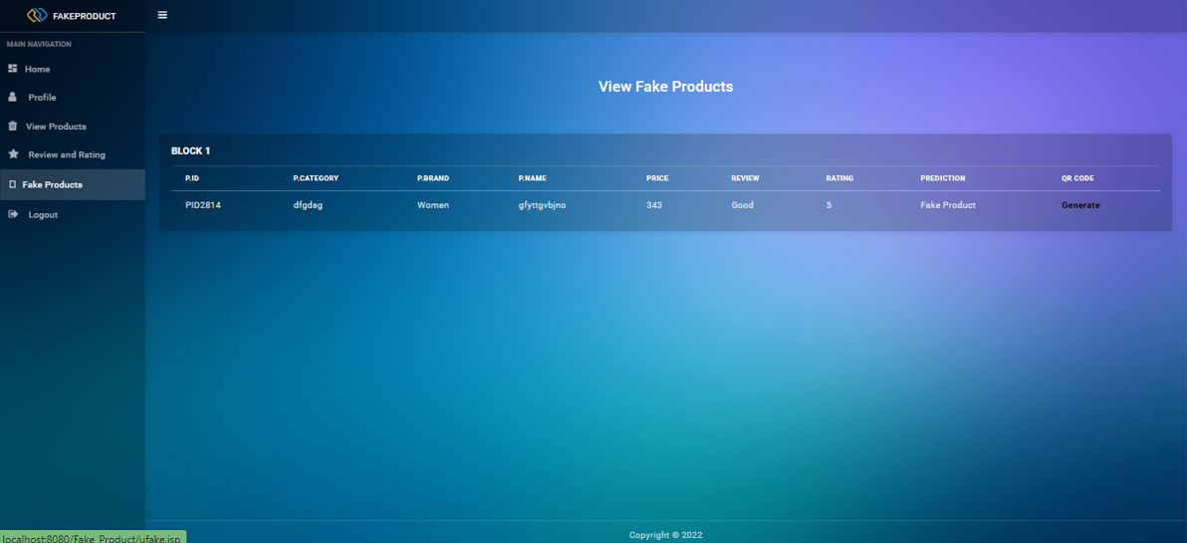

Figure:9 Result

View the Result which are the Fake Products based on user review and rating.

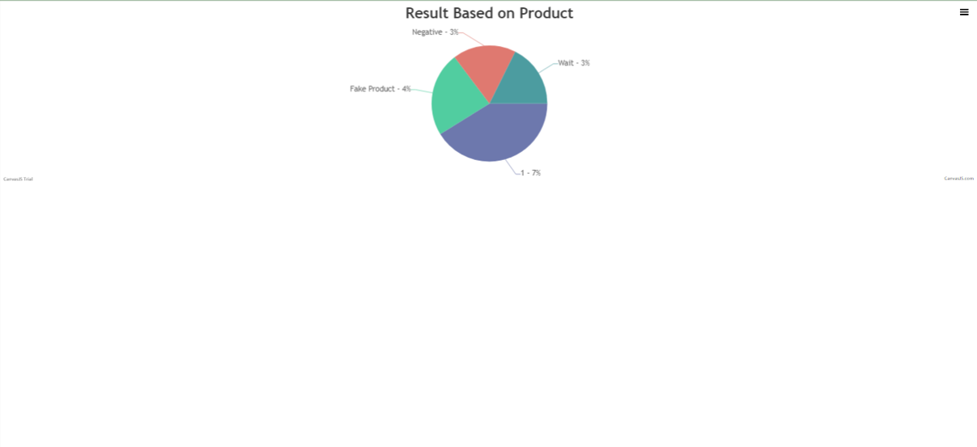

Figure:10 Result based Graph